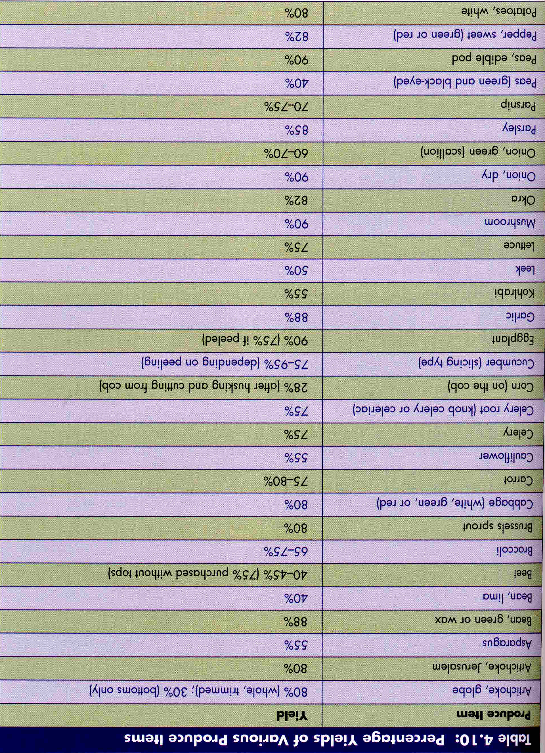
Prostart Name:_________________________
As Purchased (AP) and
Edible Portions (EP) Practice

- If you need 3lbs of trimmed celery, how much untrimmed celery should you purchase?

- If you have 5lbs of pea pods, what is your edible portion of pea pods?

- If you have 9 lbs of untrimmed okra, what is your edible portion of trimmed okra?

- If you need 5.5 lbs of trimmed broccoli, how much untrimmed broccoli will you need to purchase?

- If you have 4 lbs of untrimmed asparagus, what is your edible portion of trimmed asparagus?

