NAME: __________________________________________ DATE: _________________

PROSTART FRMCA CHAPTER 3 – EGGS AND DAIRY PRODUCTS

- DEFINE THE FOLLOWING TERMS RELATED TO MILK:

PASTEURIZATION

HOMOGENIZATION

- WHAT DO WE CALL THE MEDICAL CONDITION WHEN PEOPLE HAVE AN ALLERGIC REACTION TO DAIRY PRODUCTS AND HAVE SYMPTOMS SUCH AS STOMACH PAIN, GAS AND BLOATING?

- WHAT 3 QUALITIES DO “MILK FATS” BRING TO A DISH?

- WHICH TYPE OF MILK HAS 60% OF ITS WATER REMOVED AND HAS 6.5% FAT CONTENT?

- WHICH TYPE OF MILK HAS THE LEAST FAT AND CALORIES?

- WHICH TYPE OF MILK HAS A THICK TEXTURE, IS TANGY AND ACIDIC IN TASTE?

- FIVE BONUS POINTS: IF YOUR RECIPE CALLS FOR BUTTERMILK AND ALL YOU HAVE IS WHOLE MILK, WHAT CAN YOU DO TO MAKE A SUBSTITUTE FOR THAT BUTTERMILK?

- WHAT TYPE OF MILK IS SWEET AND HAS 60% OF WATER REMOVED?

- WHICH TYPE OF MILK HAS A LONG SHELF LIFE AND DOES NOT NEED TO BE REFIGERATED?

- NAME FOUR TYPES OF “PLANT BASED MILK”

- WHICH “PLANT BASED MILK” IS HIGHEST IN PROTEIN, HAS A NUTTY FLAVOR AND RICH TEXTURE?

- WHICH ONE HAS THE HIGHER FAT CONTENT? (CIRCLE YOUR ANSWER)
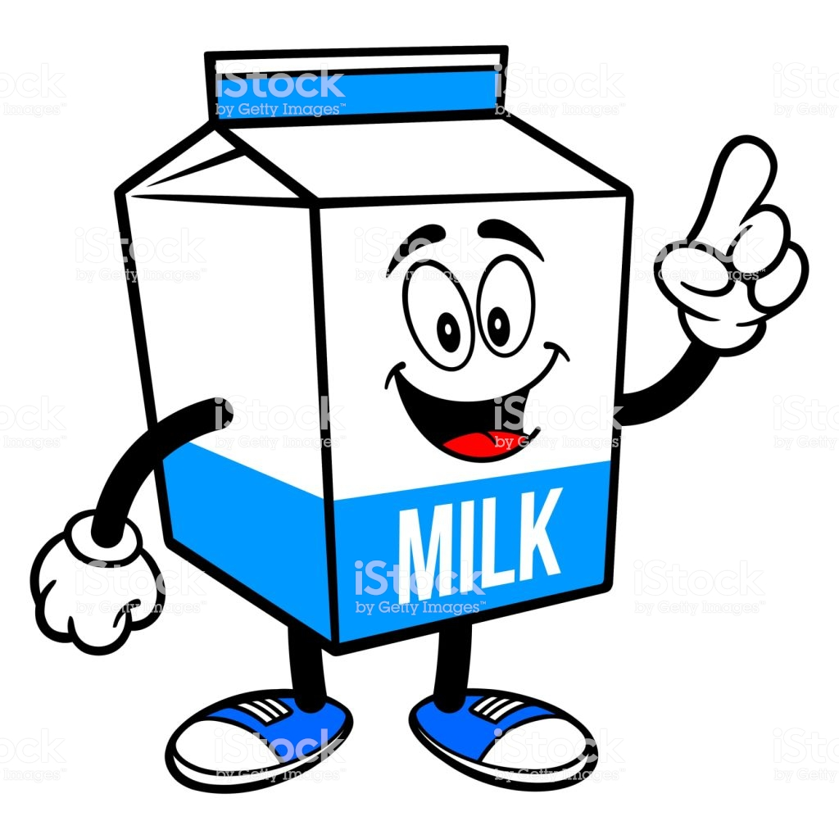
- COMPLETE THE FOLLOWING TABLE FOR SELECTED TYPES OF CREAM:

TYPE OF CREAM | FAT CONTENT | CAHRACTERISTICS
- WHAT IS THE MINIMAL AMOUNT OF FAT NEEDED IN CREAM TO BE ABLE TO HOLD WHIPPED PEAKS?

- HOW ARE “CULTURED DAIRY PRODUCTS” MADE?

- WHAT “GRADE” SHOULD ALL DAIRY AND CULTURED PRODUCTS HAVE?

- WHICH GOVERNMENT AGENCY GIVES THIS GRADE TO MILK AND DAIRY PRODUCTS?

- ALL DAIRY PRODUCTS NEED TO BE STORED AT OR BELOW WHAT TEMPERATURE?

- WHAT ARE “PROBIOTICS”?

- WHAT ARE THE 2 BEST “QUALITY GRADES” FOR BUTTER?

- WHAT IS THE MINIMAL AMOUNT OF FAT NEEDED FOR A PRODUCT TO BE CALLED “BUTTER”?

- WHAT IS THE DIFFERENCE BETWEEN “SWEET” AND “EUROPEAN STYLE” BUTTERS?

- WHAT IS MEANT BY THE “SMOKE POINT”?

- WHAT TWO THINGS ARE REMOVED FORM “CLARIFIED BUTTER”?

- WHAT ARE 4 TYPES OF “BUTTER SUBSTITUTES”:

- WHEN IT COMES TO MARGARINE, WHAT PERCENTAGE OF THE CALORIES MUST COME FROM FAT?

- WHAT ARE THE 3 BASIC COMPONENTS THAT MAKE UP CHEESE:

- COMPLETE THE FOLLOWING TABLE FOR TYPES OF CHEESE:

UNRIPENED CHEESES | RIPENED CHEESES
DEFINITION: | DEFINITION:
EXAMPLES OF: | EXAMPLES OF:

- HOW DO DAIRIES MAKE CHEESE?

- HOW ARE “PROCESSED CHEESES” MADE?

- WHAT IS THE BEST TEMPERATURE RANGE TO STORE FRESH CHEESE?

- COMPLETE THE FOLLOWING TABLE FOR VARIETIES OF CHEESE:

VARIETY | CHARACTERISTICS | EXAMPLES
VERY HARD
RIPENED CHEESE
FIRM
RIPENED

BLUE VEINED
MOLD RIPENED

PASTA FILATA

SEMI SOFT
RIPENED

- LABEL THE FOUR BASIC PARTS OF THIS EGG:

- WHICH PART OF THE EGG CONTAINS ALL OF THE FAT?

- WHAT PURPOSE DOES THE “CHALAZAE” SERVE FOR THE EGG?

- WHAT ARE THE BEST “QUALITY GRADES” FOR FRESH EGGS?

- HOW ARE THE “MARKET SIZE” FOR EGGS DETERMINED?

- COMPLETE THE TABLE FOR EGG SIZES:

EGG SIZE | WEIGHT OF EACH EGG | WEIGHT FOR A DOZEN EGGS

- HOW MANY EGGS DO WE GET IN A “DOZEN”?

- WHAT ARE THE FIVE COMMON MARKET FORMS OF EGGS AVAILABLE?

- WHICH MARKET FORM OF EGGS WOULD BE BEST USED FOR SCRAMBLED EGGS, OR FRENCH TOAST?

- FRESH EGGS DO NOT HAVE TO BE ____________________ BUT THE FOLLOWING FORMS OF EGGS MUST BE:

- WHY WOULD A HARD-BOILED EGG HAVE A GREEN YOLK?

- TELL ME THE COOKING TIMES FOR:

CODDLED EGGS | SOFT-COOKED EGGS | MEDIUM COOKED | HARD BOILED
- HOW ARE “SHIRRED EGG” DISHES PREPARED?

- NAME 2 DISHES THAT USE “POACHED EGGS”:

- WWHEN PREPARING SCRAMBLED EGGS, WHAT ARE YOU DOING TO THE EGGS WHILE THEY ARE COOKING?

- WHAT IS A “BASTED EGG”?

- DESCRIBE HOW YOU WOULD COOK AN “OVER EASY EGG”:

- EGGS THAT ARE COOKED AND SERVED IMMEDIATELY MUST REACH WHAT MINIMAL INTERNAL COOKED TEMPERATURE?

WHAT ABOUT EGGS THAT ARE GOING TO BE HELD FOR A FEW MINUTES? __________

- WHAT MAKES A “FRITATTA” SO DIFFERENT FROM AN “OMELET”?

- WHAT MAKES “SOUFFLES” POPUP AND BE PUFFY WHEN PROPERLY BAKED?

- WHAT IS THE DEFINITION OF A “QUICHE”?

- WHAT DOES IT MEAN TO “POOL EGGS”?

